**Polytechnic University of the Philippines  
College of Computer and Information Sciences**  **Sta. Mesa, Manila**

**Majent Management and Development Corporation: Building Unit Lease Management System**

**Submitted in partial fulfillment of the requirements for  
Systems Analysis and Design**

**Submitted by:**

**Atienza, Christopher**

**Layug, Reynald Chris**

**Reyes, Merly Joy**

**Santiago, Jose Fetemanaldo**

**Tan, Kenneth**

**Vicente, Venmar**

**Chapter I: Project Definition**

1. **Introduction**

Leasing by definition is a written or implied contract by which an owner (the lessor) of a specific asset (such as a parcel of land, building, equipment, or machinery) grants a second party (the lessee) the right to its exclusive possession and use for a specific period and under specified conditions, in return for specified periodic rental or lease payments.

Leasing Department inside Majent Management and Development Corporation handles properties of MGC as well as their own property such as Menarco Tower and K Malls. They also handle condo units, offices and house and lot. They act as the owner side.

However, the leasing department is experiencing problems that the proposed project will address.

* Overlapping of information such as dates of lease term.
* Poor maintenance of the client’s contract.
* Voluminous paper storage (Contract Forms) and hard retrieval of old files.

1. **Business Case**
   1. **Background of the Organization**

Majent Management and Development Corporation specializes in Real Estate Leasing Business. They handling properties of MGC as well as their own property such as Menarco Tower which is under construction. They also handling K-Malls in Silang, Calamba and Tagaytay, condo units and offices, and house and lot.

* 1. **Project Overview**

The project is about managing the lease of a tenant to the companies building. The project will be having four modules for maintenance which are Buildings (Buildings, Building Type, Floors, Units), Banks, Payment Terms, Business Type. Four modules for transaction which are Create Contract, Extend Contract, Termination of Contract, Amendment Contract, Addendum of Contract, and Billing.

Majent Management and Development Corporation: Building Unit Lease Management System consists two sub-systems. First is ***Contract management system*** which includes the renewal of the contract, extension and when it will expire. Second is ***Billing Collection System*** consisting the billing information of the lessee.

* 1. **Project Constraints**
* Scope

The team will know the scope of the business for the team to know the limitation of the project, of what must do/ don’t for the project.

* Budget

Money shortage may cause problems in project delay like printing of the project or any activity related of producing the project.

* Time

The team will strategize their time because of it is very limited for the project to finish.

* 1. **Project Assumptions**
* Availability of Resources

The team will have resources for the project to accomplish the goals. Resources such as forms from the company and other that is needed for the project.

* Expenses

The team will expect expenses for the completion of the project. Expenses such as printing and other unexpected expenses like food expenses and fare expenses.

* Team and Client Cooperation

The team will interview their client about the project to know if there is not clear information about their business processes, the team will simply ask their client.

* User’s Acceptance

The team will know the preferences of the client. The client must test the system whether he/she will approve about the project made by the team.

1. **Methods Used in the Study**

**Gathering Techniques**

* Client Interview

The team will use interview which is the most common technique in gathering requirements and information. The team will have a client meet ups in order to gather requirements completely and understand transactions responsibly.

* Observation

The team will also use observation technique with regards to the process of transactions throughout the company.

**Software Development Used**

* Iterative Waterfall Model

The team will use Iterative waterfall model. It is less risk than a traditional Waterfall model. The whole team will remain focused on delivering the end goal, not the separate phases.

**Chapter 2: Functional Specification Report**

**2.1 Data Requirements**

**2.1.1 Forms**

**2.1.1.1 List of Forms**

|  |  |  |
| --- | --- | --- |
| No. | Name | Description |
| 1 | Client Registration Form | This form is used by and filled by the people/client who wants to rent a space. |
| 2 | Offer Sheet | This form contains information regarding the available lease unit that is suitable to the client’s business. |
| 3 | Contract of Lease | This form contains contract for leasing including the billing information, and company requirements. |
| 4 | Contract for Extension of Lease | This form contains contract for extending the lease of client which includes the billing information and is noted by the attorney. |
| 5 | Move out Clearance Form | This form contains contract for moving out things from the building. |
| 6 | Tenant Information Sheet | This form contains information of the company tenant such as their executive’s information. |

**2.1.1.2 Sample Forms**

Figure 1: Registration Form

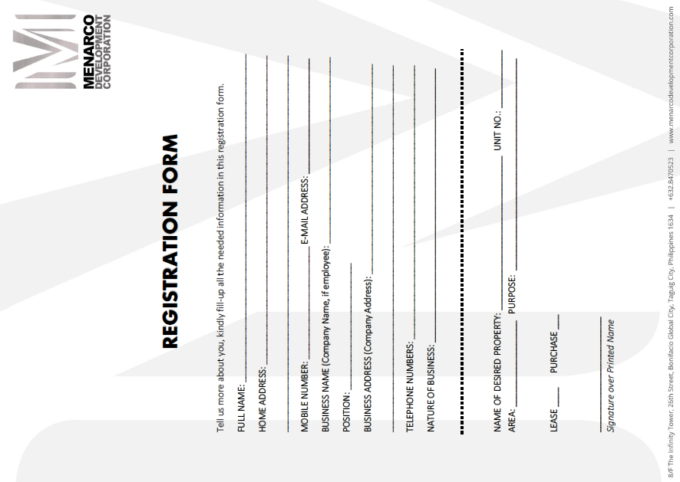

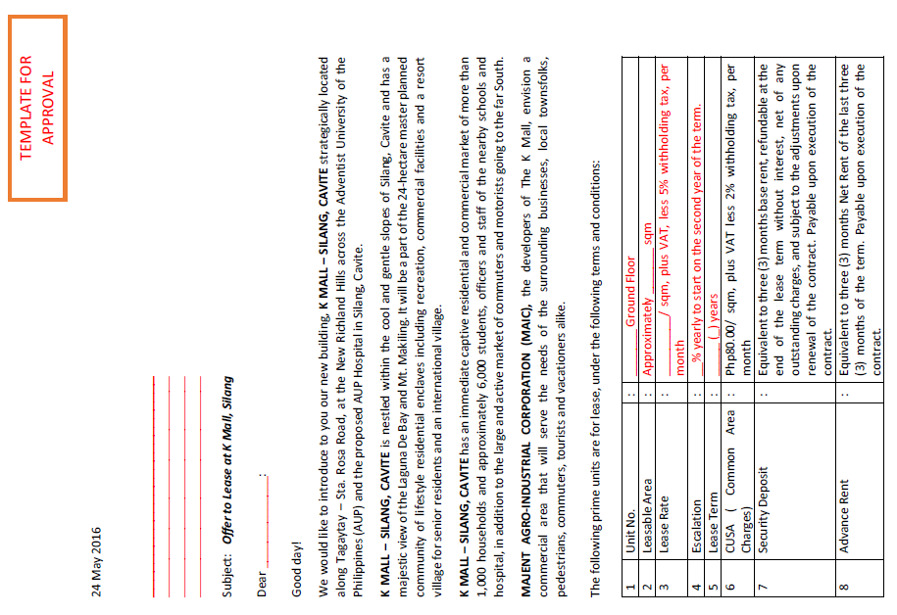

Figure 2: Offer Sheet

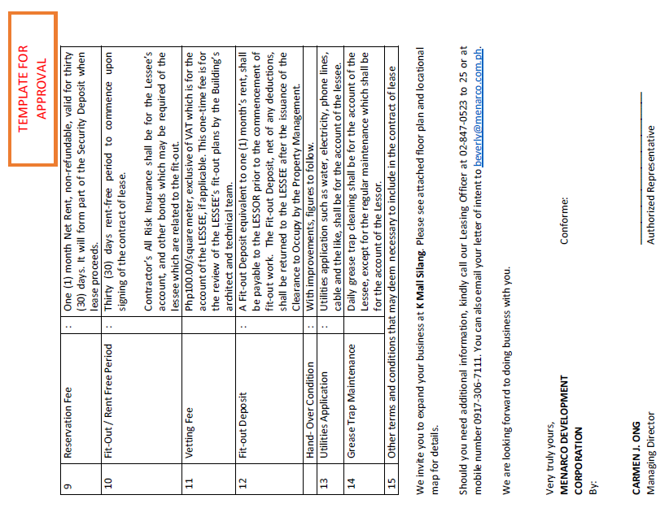

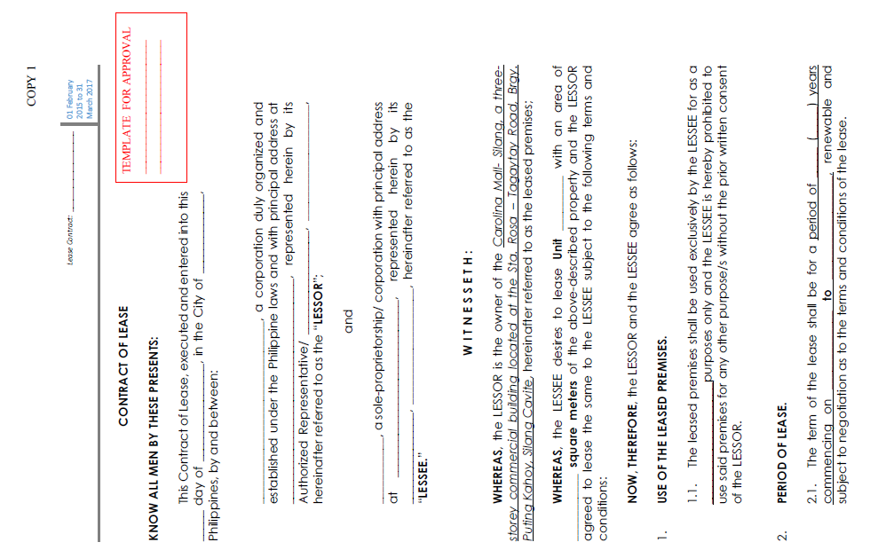

Figure 3: Contract of Lease

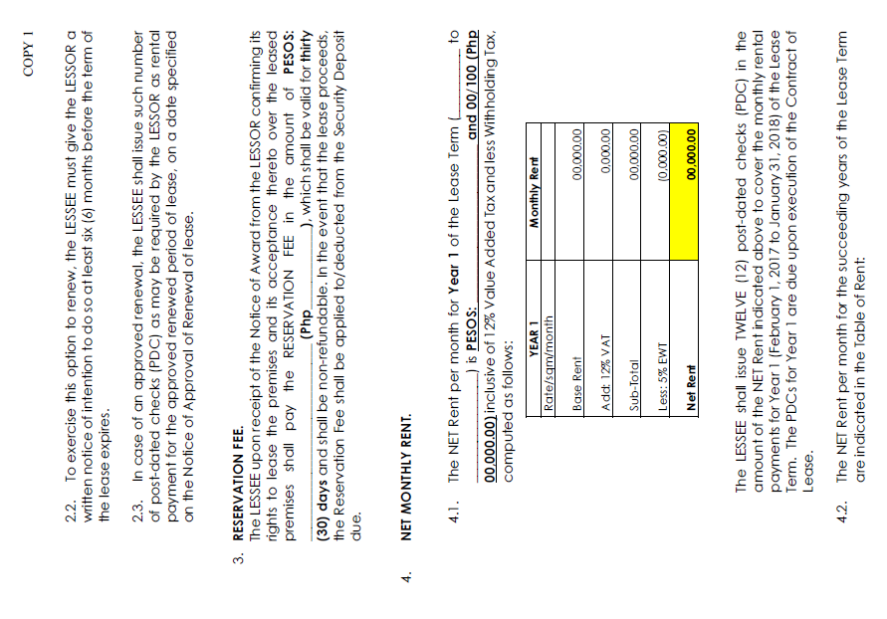

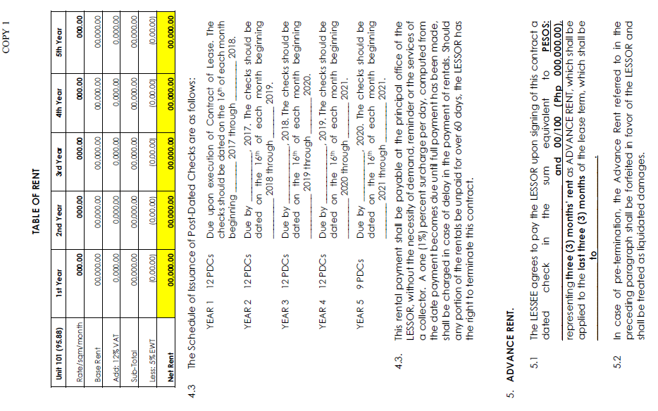

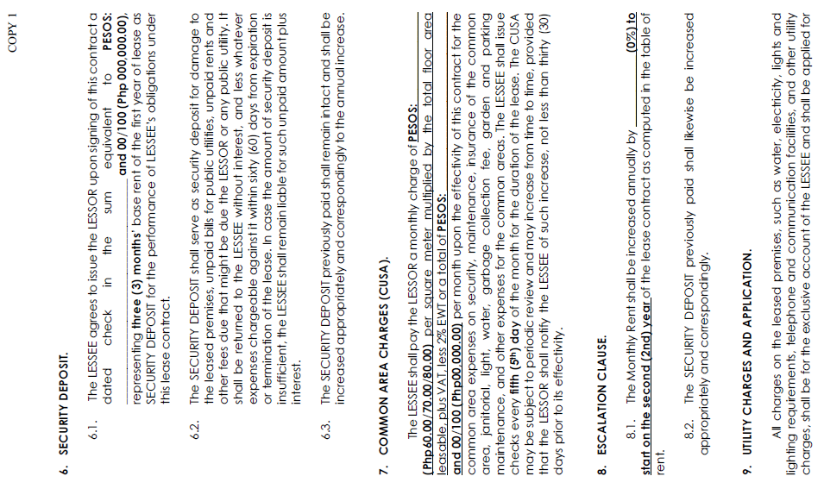

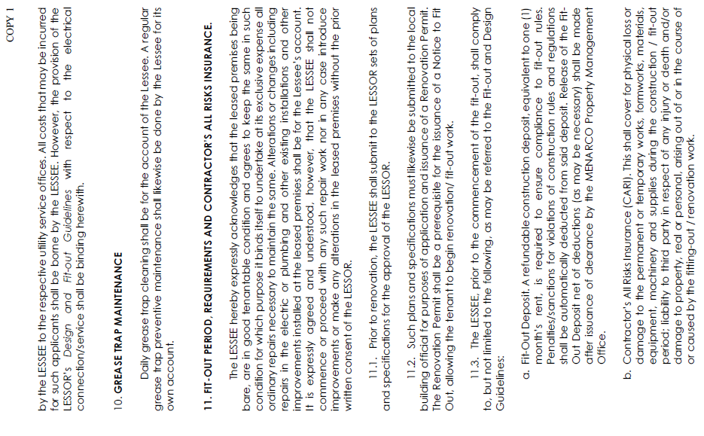

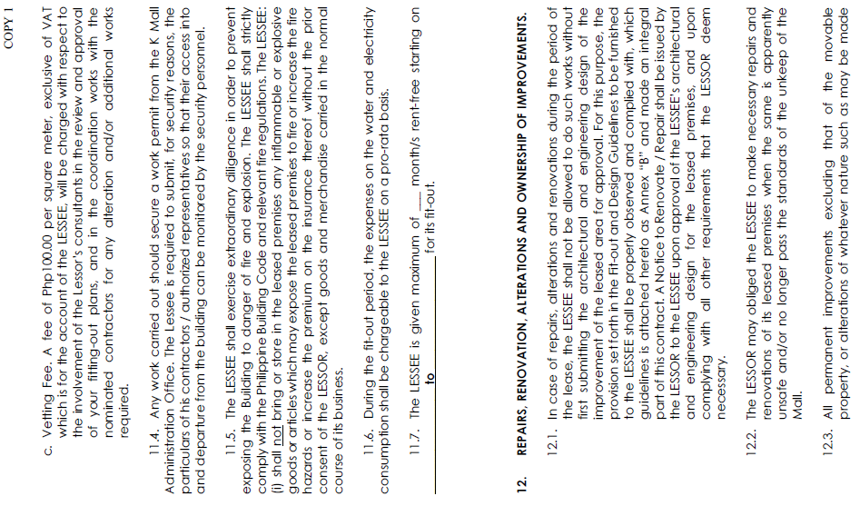

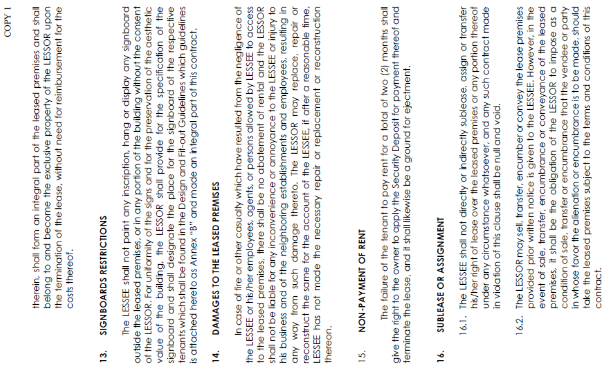

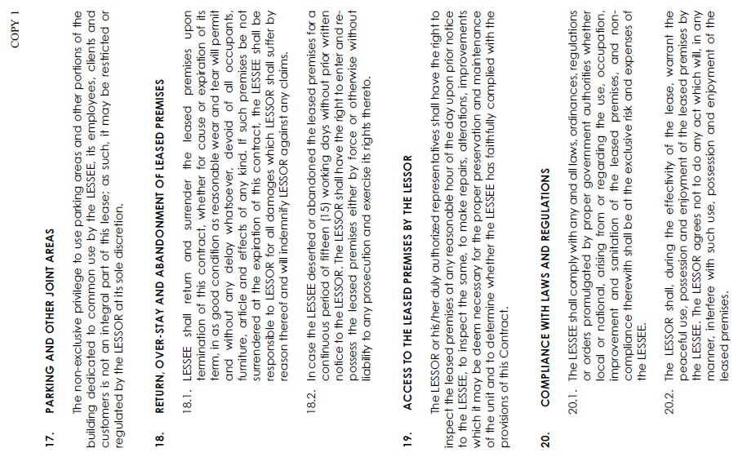

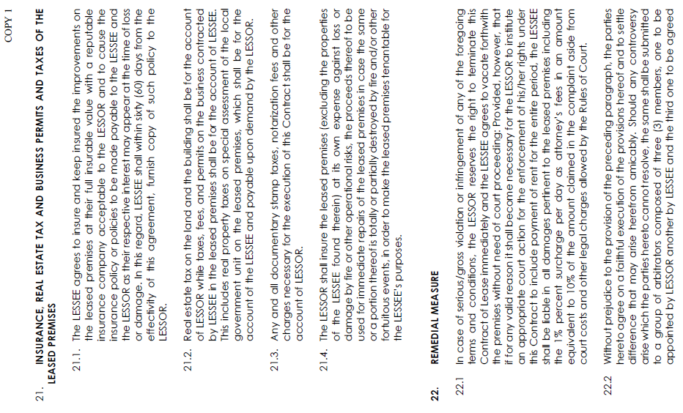

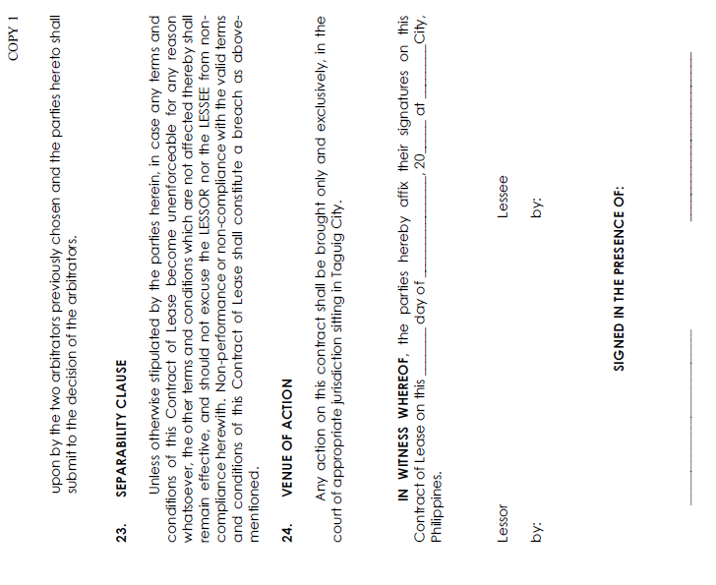

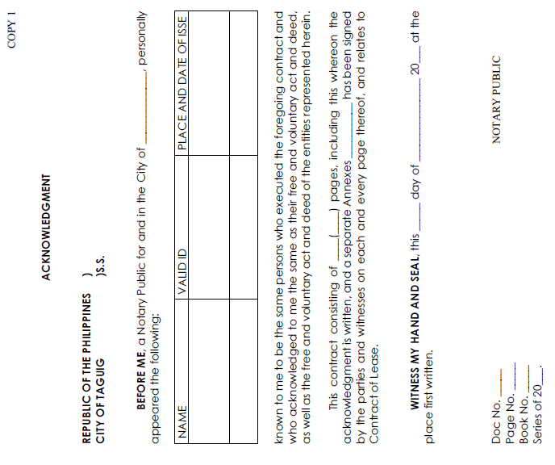

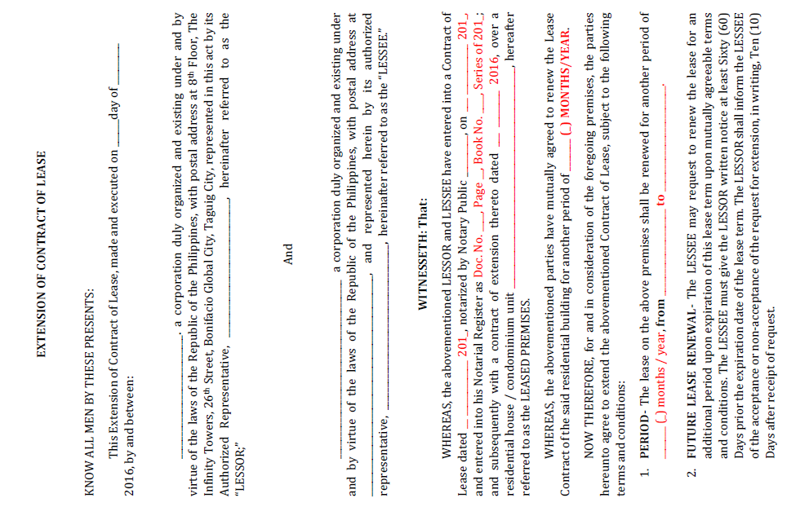

Figure 4: Contract for Extension

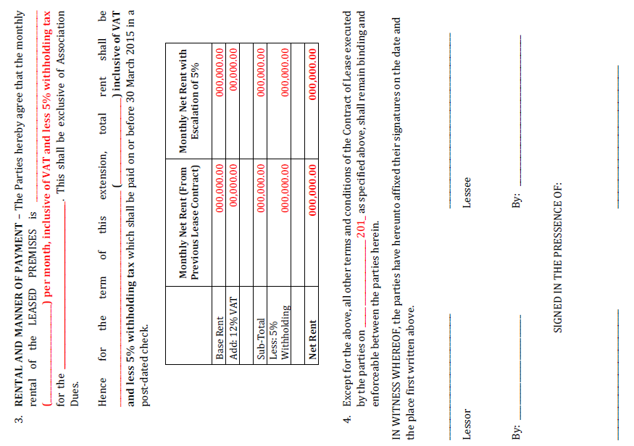

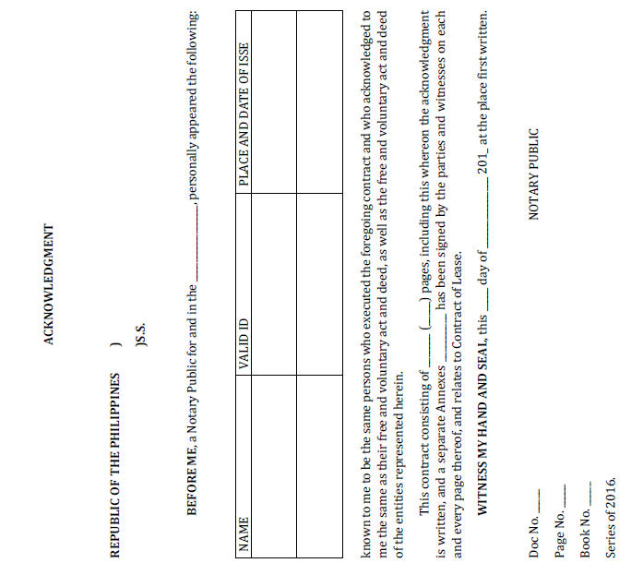

**2.1.2 Reports**

**2.1.2.1 List of Reports**

|  |  |  |
| --- | --- | --- |
| No. | Name | Description |
| 1 | Schedule of Occupancy | A type of report that shows list of lessee by property, are, rental rate, and lease term. |
| 2 | Summary of Occupancy | A type of report that shows the tenant’s information. |
| 3 | Summary of Accounts | A type of report that shows the account’s summary. |
| 4 | Collection Report | A type of report that shows the billing collection. |

**2.1.2.2 Sample Reports**

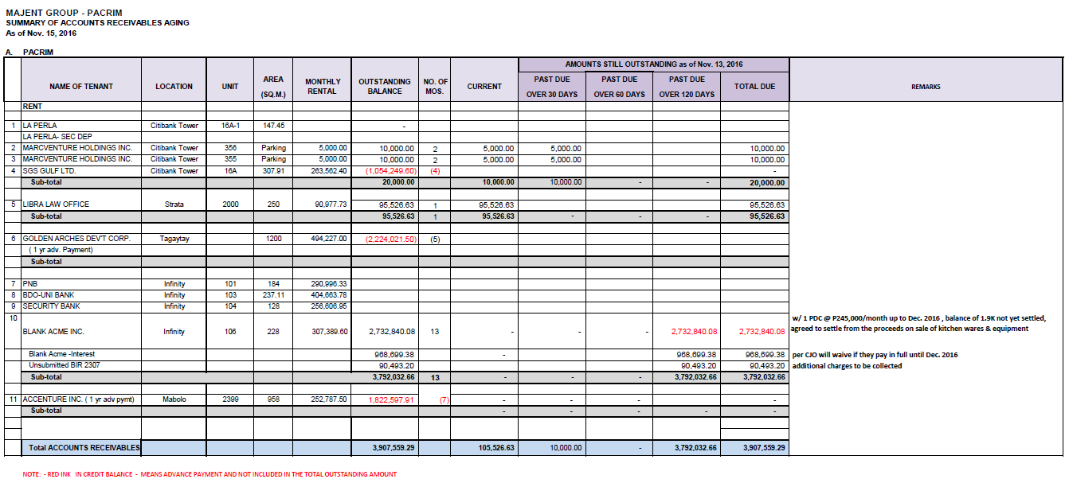**Summary of Accounts**

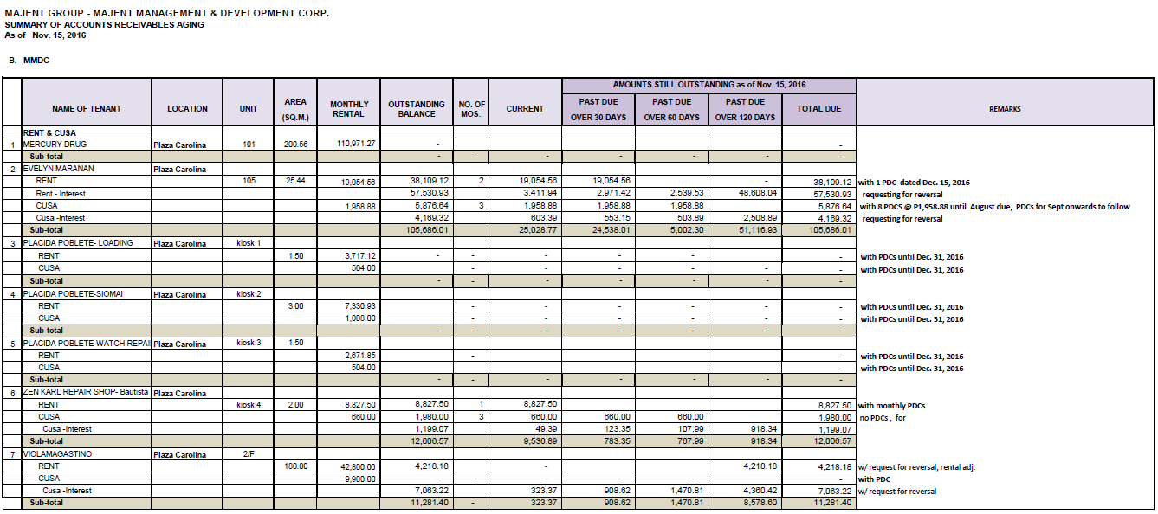

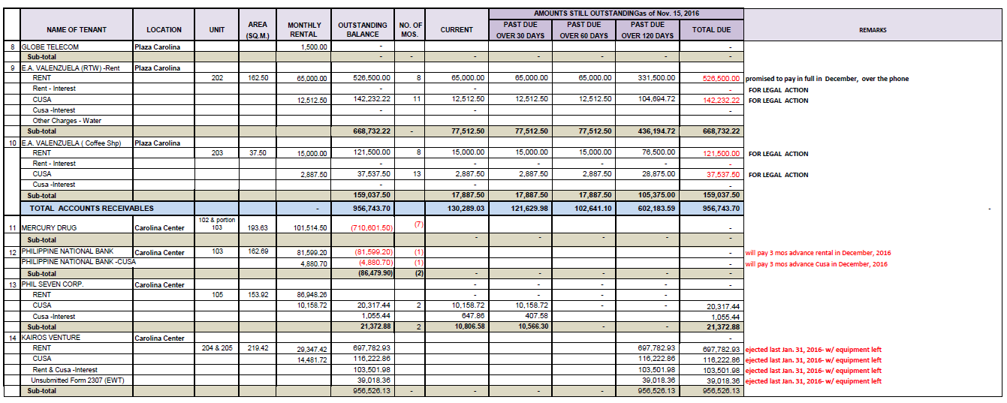

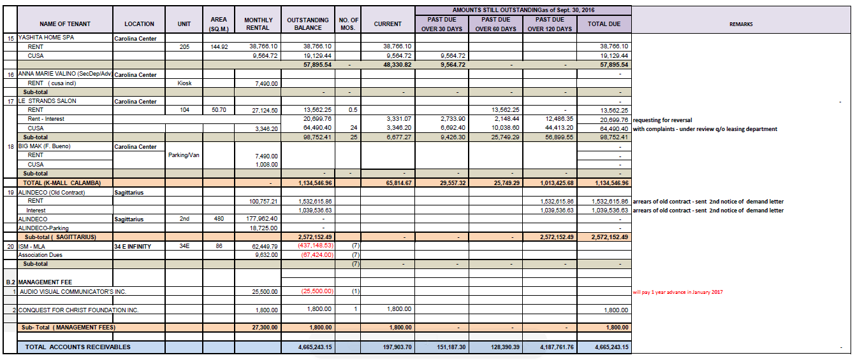

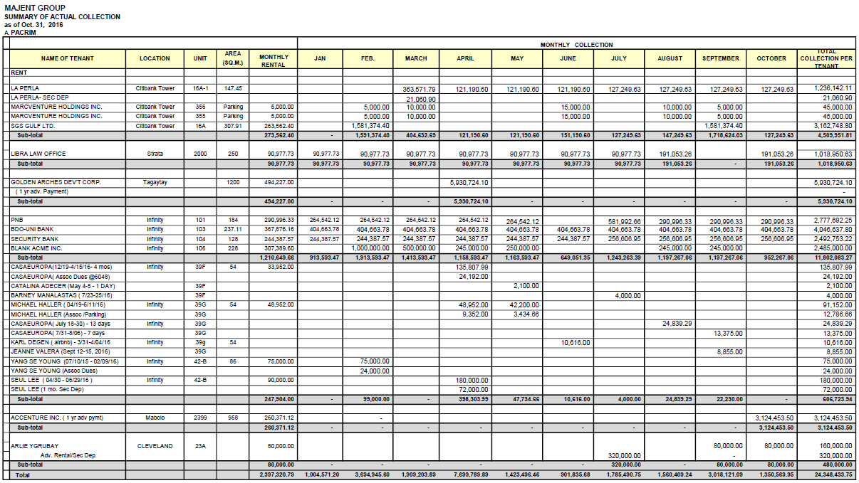**Collection Report**

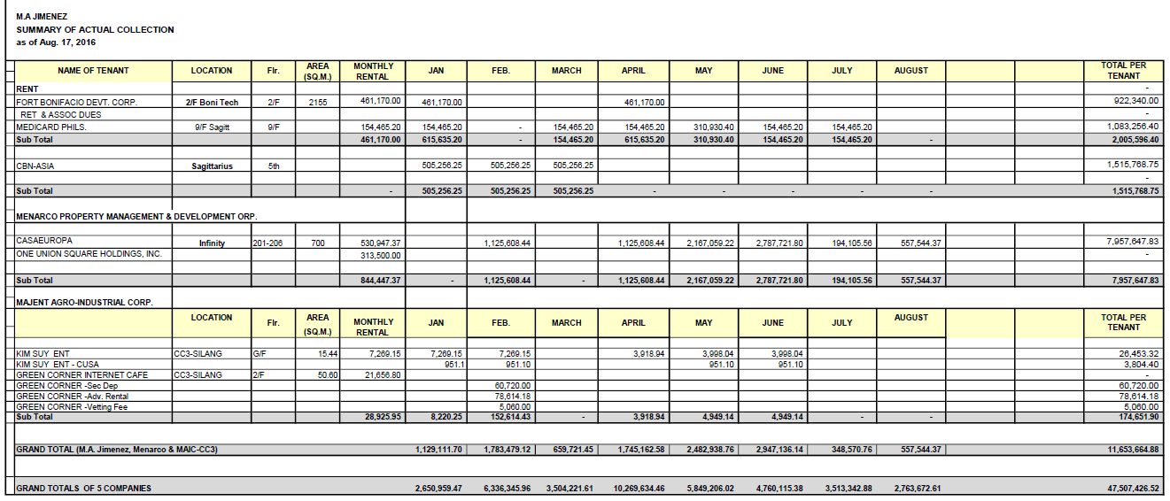

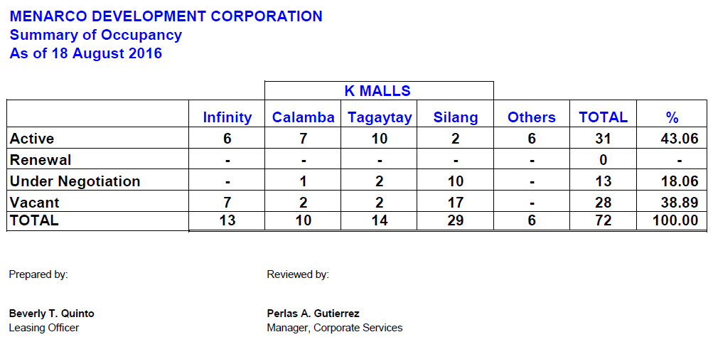**Summary of Occupancy**

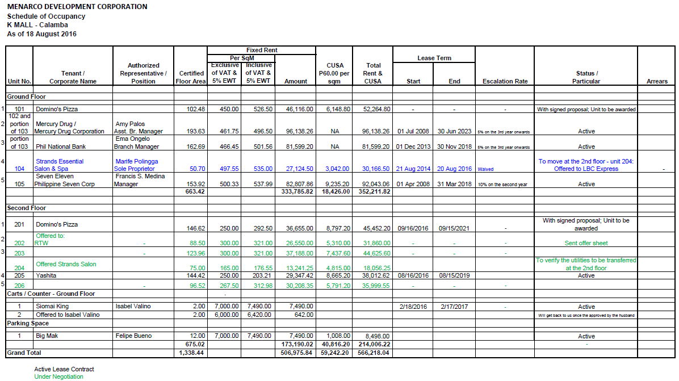**Schedule of Occupancy**

**2.2.2 Policies**

**2.2.2.1 Business Requirements**

|  |  |
| --- | --- |
|  | Business Requirements |
| BR-01 | Letter of Intent |
| BR-02 | Business Concept Paper |
| BR-03 | Company Profile |
| BR-04 | SEC Cert of Registration, Incorporation and By-laws (if applicable) |
| BR-05 | DTI Registration |
| BR-06 | Latest Financial Statement, if with existing business |
| BR-07 | General Information Sheet (latest) |
| BR-08 | BIR Registration Cert (Form 2303) |
| BR-09 | Bank Certificate |
| BR-10 | Any other document that may be required in assessing/evaluating application |
| BR-11 | Tenant Registration Form |
| BR-12 | Signed Term Sheet |
| BR-13 | Signed Contract of Lease |

**2.2.2.2 Business Policies**

|  |  |
| --- | --- |
|  | Business Policies |
| BP-01 | The lessee must inquire to the company through phone calls. |
| BP-02 | The minimum contract duration for commercial lessee is 2 years. |
| BP-03 | The minimum contract duration for residential lessee is 1 year. |
| BP-04 | The lessee must have letter of intent for the approval of the company. |
| BP-05 | The lessee must get a lease offer from the management to offer available units that is suitable to the lessee needs. |
| BP-06 | The lessee shall give their business concept and layout plans before the contract signing |
| BP-07 | Equivalent to three (3) months base rent, refundable at the end of the lease term without interest, net of any outstanding charges, and subject to the adjustments upon renewal of the contract. |
| BP-08 | Equivalent to three (3) months Net Rent of the last three (3) months of the term, payable upon execution of the contract. |
| BP-09 | One (1) month Net Rent, non-refundable, valid for thirty (30) days. It will form part of the Security Deposit when lease proceeds. |
| BP-10 | Thirty (30) days rent-free period to commence upon signing of the contract lease. Contractor’s All Risk Insurance shall be for the Lessee’s account, and other bonds which may be required of the lessee which are related to the fit-out. |
| BP-11 | Php100.00/square meter, exclusive of VAT which is for the account of the LESSEE’s fit-out plans by the Building’s architect and technical term. |
| BP-12 | A Fit-out Deposit equivalent to one (1) month’s rent, shall be payable to the LESSOR prior to the commencement of fit-out work. The Fit-out Deposit, net of any deductions, shall be returned to the LESSEE after the issuance of the Clearance to Occupy by the Property Management. |
| BP-13 | With improvements, figures to follow. |
| BP-14 | Utilities application such as water, electricity, phone lines, cable and the like, shall be for account of the lessee. |
| BP-15 | Daily grease trap cleaning shall be for the account of the Lessee, except for the regular maintenance which shall be for the account of the lessor. |
| BP-16 | Other terms and conditions that may deem necessary to include in the contract of lease. |

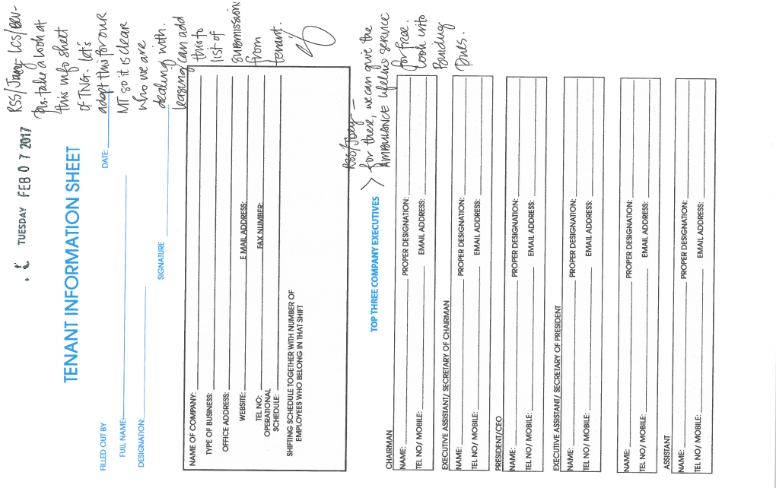

Figure 5: Tenant Information Sheet

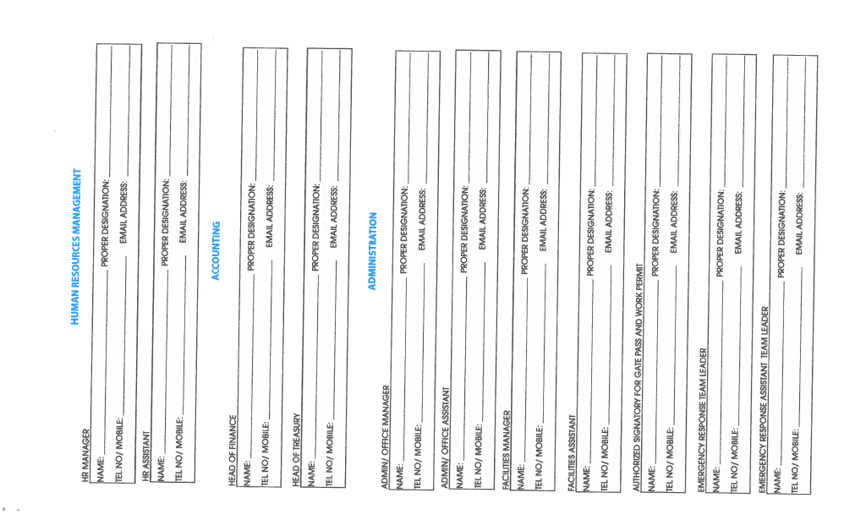

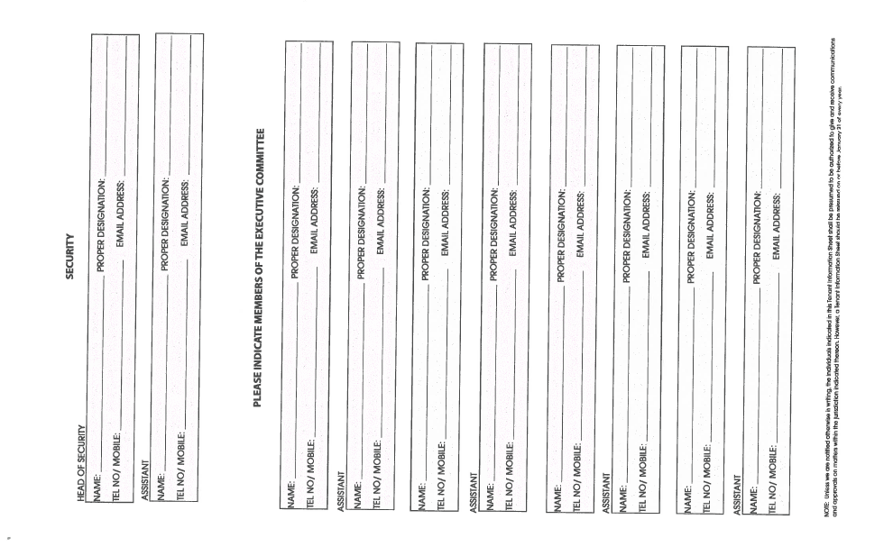

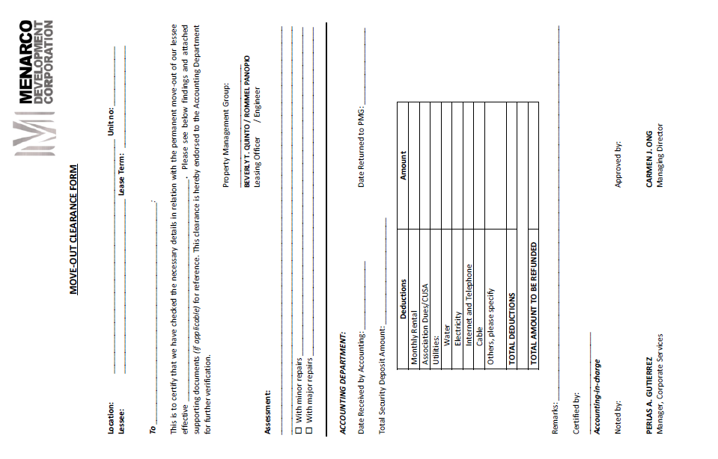

Figure 6: Move out Clearance Form

**2.2 Policies and Procedures**

**2.2.1 Procedures**

**2.2.1.1 Context Diagram**

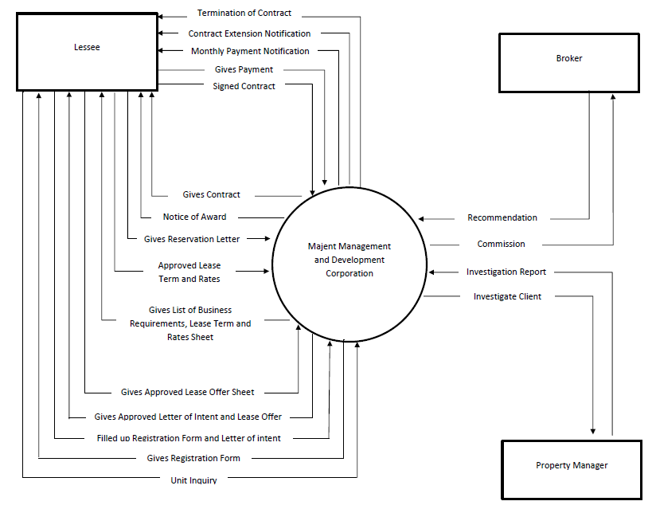

**2.2.1.2 DFD Level 1**

1

Process Registration

Unit Inquiry

Lessee

Give Requirements

Give Registration form

Lessee file

Gives lease offer Filled registration form

2

Lease Document Process

Give Letter of intent

Approved letter of intent

Gives lease offer

Property Manager

Gives Business concept Validated letter of intent

Approve Lease offer Give letter of intent

Give term sheet

Approved term sheet

3 Manage Contract

Give Contract

Signed Contract

List of Contract

Gives reservation letter

4

Manage Payment

Give notice of award

Signed contract

Payment Records

Gives Notification Give Commission

Gives PDC Payment

Broker

5

Generate Reports

Leasing Update

Schedule of Occupancy

Property Manager

Report Request

Give Report

**DFD LEVEL 2**

**PROCESS REGISTRATION**

1.1

Inquiry Unit

Unit details

Give Requirements

Get details

1.2

Registration

Give personal Info Store temporarily

Lessee file

Give status

Validated data

Property Manager

Get Lessee data

**LEASE DOCUMENT PROCESS**

Give letter of intent

2.1

Letter of intent

Give Business Concept

List of letter of intent

Gives justification of space and rental rate

Approve Letter of intent

Validated letter of intent

Give Approve letter

Of intent

Property Manager

2.2

Lease offer

Give Business Requirement

List of letter of intent

Approve Lease offer

Give Layout plan

2.3

Term sheet

Gives Term period, CUSA

Gives Lease Rate sheet

Approve term sheet

**MANAGE CONTRACT**

3.3

Contract Termination

3.2

Contract Extension

3.1

New Contract

Give new Contract

Review Contract

Signed Contract

Give Contract Payment

Monthly Payment Notification

Notification for extension

Approved extension

List of Contract

Give Contract for extension

Review Contract

Signed Contract

Give contract extension payment

List of Amendment

Notification for termination

Approved termination

Give Contract for termination

Signed Contract

List of Addendum

3.4

Contract Amendment

3.5

Contract Addendum

Request for amendment

Unit detail,Lease rate

Request for adding units

Unit detail,Lease rate

**a2.3 Problem Analysis**

**2.3.1 Fishbone**

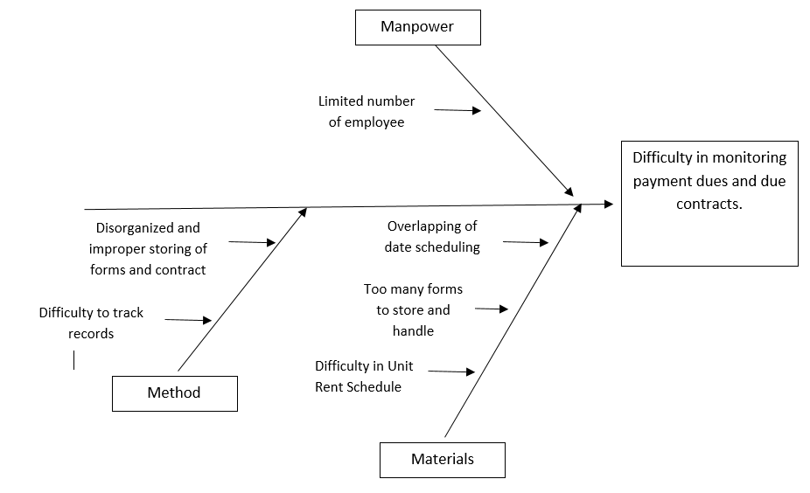

Completion of task takes too much time and effort

**2.3.2 Conclusion**

The researchers have found out that there were problems affecting the business. Poor maintenance of clients' contract such as the disorganized and improper storing of forms and contract may result to difficulty in tracking the client’s records. Therefore, the leasing officer might encounter trouble in unit rent schedule like overlapping date scheduling. Thus, difficulty in retrieving and updating client’s records, and difficulty in prompting contract scheduling is the main problem. Based on findings, the company can earn more profit if they monitor information of all tenant information per unit, income, and expense reports.

**2.3.3 Recommendation**

The researchers highly recommend the proposed system which is Majent Management and Development Corporation: Building Unit Lease Management System consists of two subsystems which are Contract Management, Billing and Collection.

Contract management system which includes the renewal of the contract, extension and when it will expire. Second is Billing Collection consisting the billing information of the lessee.

The researchers also recommended the proposed mobile application that features Client Notification and Client Investigations.

**Chapter 3: Proposed System Definition**

**3.1 Functional Specifications**

**3.1.1 System Boundaries**

**3.1.1.1 System Use Case Diagram**

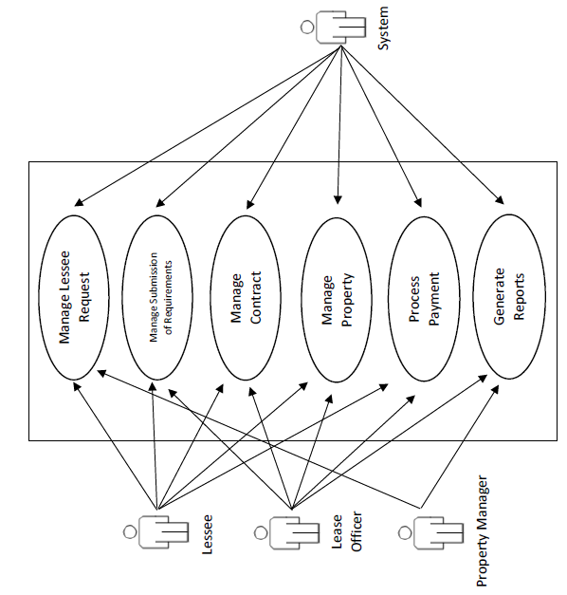Majent Management and Development Corporation: Building Unit Lease Management System

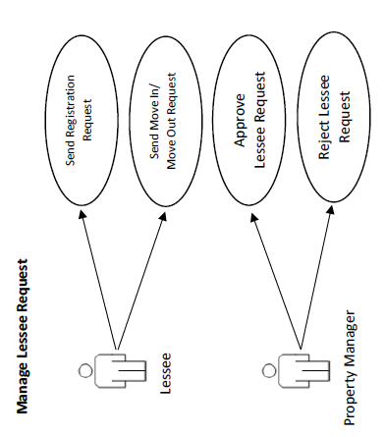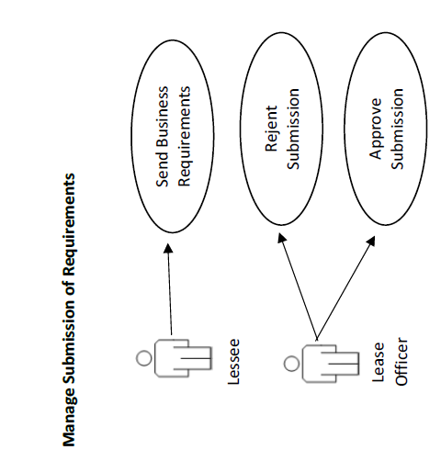

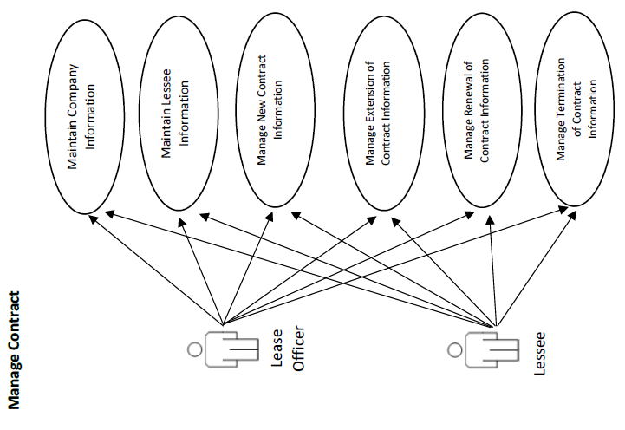

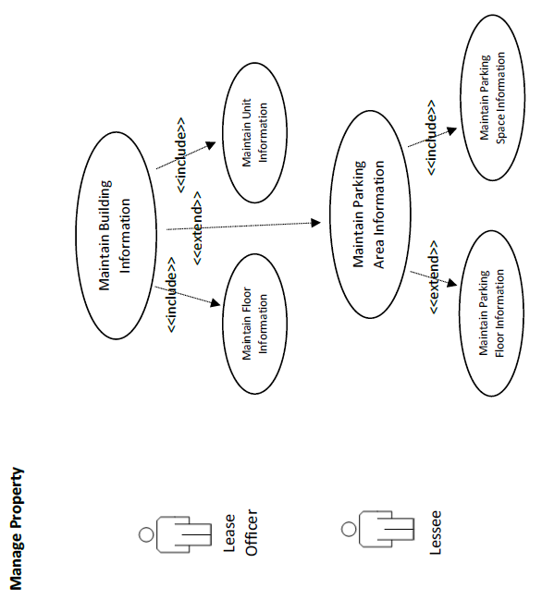

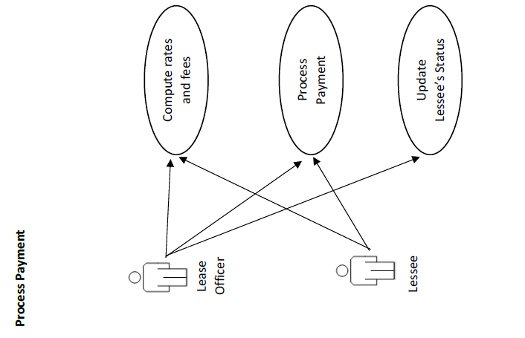

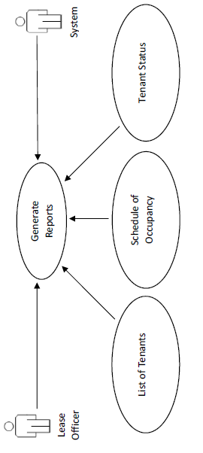

**Generate Reports**

**3.1.2 System Flow**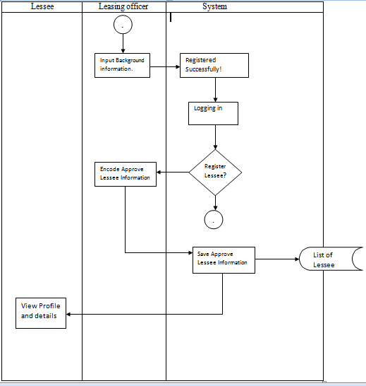

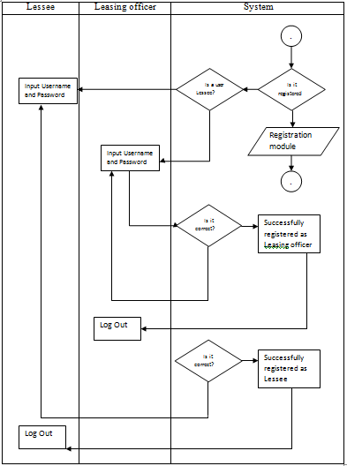

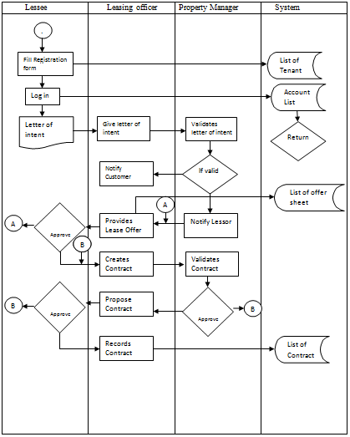

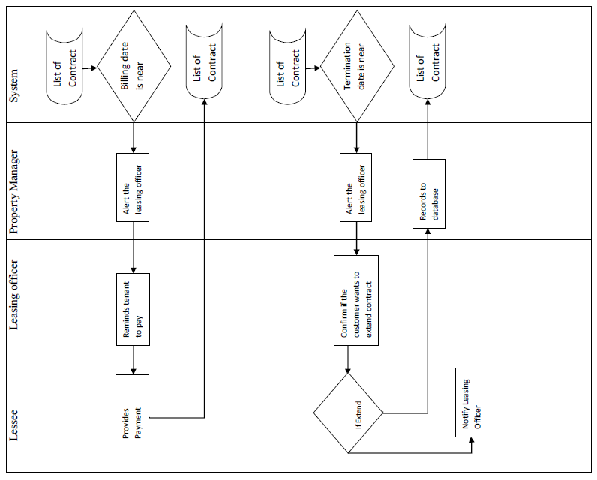

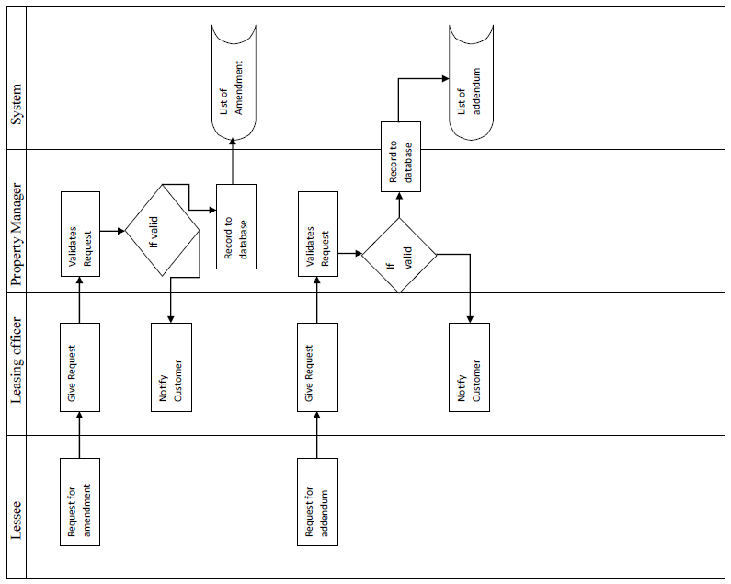

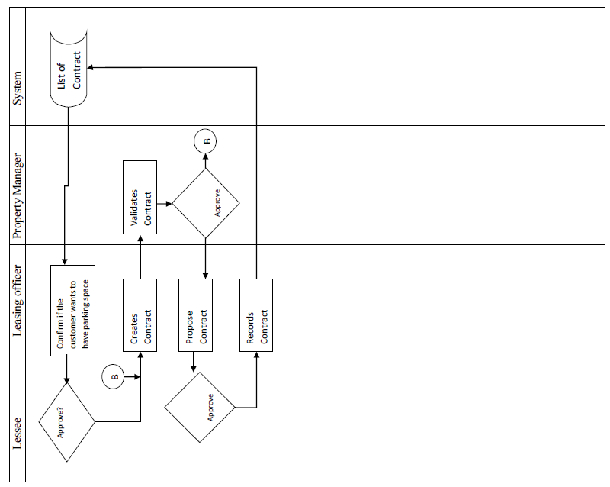

**3.2 Technical Specifications**

**3.2.1 Domain Object Modelling**

**3.2.1.1 Data Dictionary of Classes**

|  |  |  |  |  |  |
| --- | --- | --- | --- | --- | --- |
| TABLE NAME: tblBuildingType | | | | | |
| TABLE DESCRIPTION: This table has the information about the building type | | | | | |
|  | | | | | |
| ID | **FIELD** | **DESCRIPTION** | **DATA TYPE** | **LENGTH** | **SAMPLE** |
|  |  |  |  |  |  |
| PK | intBuildTypeCode | Unique Identifier for Building Type | Int |  | 001 |
|  | strBuiltTypeDesc | Description of the Building Type | Char | 30 | Mall |
|  | boolIsActive | Indicator for status | boolean |  | 1 |
|  | boolIsDeleted | Indicator for existence of record | boolean |  | 1 |

|  |  |  |  |  |  |
| --- | --- | --- | --- | --- | --- |
| TABLE NAME: tblBuilding | | | | | |
| TABLE DESCRIPTION: This table has the information about the building | | | | | |
|  | | | | | |
| ID | **FIELD** | **DESCRIPTION** | **DATA TYPE** | **LENGTH** | **SAMPLE** |
|  |  |  |  |  |  |
| PK | intBuilCode | Unique Identifier for Building | Int |  | 001 |
|  | strBuilCode | Identifier for Building | Char | 20 | BUIL-001 |
|  | strBuilDesc | Description of the Building | Char | 30 | Menarco |
|  | intBuilNumOfFloor | Number of floors in building | Int |  | 23 |
| FK | intBuilTypeCode | Identifier of building type code | Int |  | 004 |
| FK | intBuilAddCode | Identifier of building address code | Int |  | 012 |
|  | boolIsActive | Indicator for status | boolean |  | 1 |
|  | boolIsDeleted | Indicator for existence of record | boolean |  | 1 |

|  |  |  |  |  |  |
| --- | --- | --- | --- | --- | --- |
| TABLE NAME: tblFloor | | | | | |
| TABLE DESCRIPTION: This table has the information about the Unit | | | | | |
|  | | | | | |
| ID | **FIELD** | **DESCRIPTION** | **DATA TYPE** | **LENGTH** | **SAMPLE** |
|  |  |  |  |  |  |
| PK | intFloorCode | Unique identifier for floor | Int |  | 013 |
|  | intFloorNum | Floor Number | int |  | 13 |
| FK | intBuilCode | Foreign Key of the building | int |  | 005 |
|  | intNumberOfUnits | Number of Units | Int |  | 32 |
|  | boolIsActive | Indicator for status | boolean |  | 1 |
|  | boolIsDeleted | Indicator for existence of record | boolean |  | 1 |

|  |  |  |  |  |  |
| --- | --- | --- | --- | --- | --- |
| TABLE NAME: tblUnit | | | | | |
| TABLE DESCRIPTION: This table has the information about the Unit | | | | | |
|  | | | | | |
| ID | **FIELD** | **DESCRIPTION** | **DATA TYPE** | **LENGTH** | **SAMPLE** |
|  |  |  |  |  |  |
| PK | intUnitCode | Unique identifier for unit | Int |  | 1232 |
|  | strUnitCode | identifier for unit | Char | 20 | MENA-UNIT-1232 |
|  | strUnitType | Type of unit | Int |  | 1 |
| FK | intFloorCode | Foreign Key of the floor | Int |  | 005 |
|  | dblUnitArea | Amount of unit per area | Double |  | 50.00 |
|  | intUnitNumber | Unit number | Int |  | 32 |
|  | boolIsActive | Indicator for status | boolean |  | 1 |
|  | boolIsDeleted | Indicator for existence of record | boolean |  | 1 |

|  |  |  |  |  |  |
| --- | --- | --- | --- | --- | --- |
| TABLE NAME: tblUnitPrice | | | | | |
| TABLE DESCRIPTION: This table has the information about the Unit price | | | | | |
|  | | | | | |
| ID | **FIELD** | **DESCRIPTION** | **DATA TYPE** | **LENGTH** | **SAMPLE** |
|  |  |  |  |  |  |
| FK | intUnitPriceCode | Unique Identifier for Price of unit | Int |  | 340 |
|  | datUnitPriceDateAsOf | Date of unit price | Date |  | 2014-12-19 |
|  | dblUnitPrice | Price of unit | Double |  | 200000.00 |

|  |  |  |  |  |  |
| --- | --- | --- | --- | --- | --- |
| TABLE NAME: tblParkRate | | | | | |
| TABLE DESCRIPTION: This table has the information about the Park Rate | | | | | |
|  | | | | | |
| ID | **FIELD** | **DESCRIPTION** | **DATA TYPE** | **LENGTH** | **SAMPLE** |
|  |  |  |  |  |  |
| FK | intBuilCode | Unique Identifier for park rate | Int |  | 340 |
|  | datParkRateDate | Date of Park rate | Date |  | 2013-10-9 |
|  | dblParkRate | Park Rate | Double |  | 6000.00 |

|  |  |  |  |  |  |
| --- | --- | --- | --- | --- | --- |
| TABLE NAME: tblParkArea | | | | | |
| TABLE DESCRIPTION: This table has the information about the park area | | | | | |
|  | | | | | |
| ID | **FIELD** | **DESCRIPTION** | **DATA TYPE** | **LENGTH** | **SAMPLE** |
|  |  |  |  |  |  |
| PK | intParkAreaCode | Unique Identifier for Park Area | Int |  | 001 |
|  | strParkAreaDesc | Identifier for Park Area | Char | 10 | PA-1121 |
| FK | intFloorCode | Foreign Key for Floor | int |  | 011 |
|  | intNumOfSpace | Number of space | Int |  | 23 |
|  | dblParkAreaSize | Park Area Size | Double |  | 30.00 |
|  | boolIsActive | Indicator for status | boolean |  | 1 |
|  | boolIsDeleted | Indicator for existence of record | boolean |  | 1 |

|  |  |  |  |  |  |
| --- | --- | --- | --- | --- | --- |
| TABLE NAME: tblParkSpace | | | | | |
| TABLE DESCRIPTION: This table has the information about the park space | | | | | |
|  | | | | | |
| ID | **FIELD** | **DESCRIPTION** | **DATA TYPE** | **LENGTH** | **SAMPLE** |
|  |  |  |  |  |  |
| PK | intParkSpaceCode | Unique Identifier for Park Space | Int |  | 001 |
|  | strParkSpaceDesc | Identifier for Park Space | Char | 10 | PS-3221 |
| FK | intParkAreaCode | Foreign Key for Floor | int |  | 011 |
|  | intParkSpaceNum | Number of space | Int |  | 21 |
|  | dblParkSpaceSize | Park Area Size | Double |  | 30.00 |
|  | boolIsActive | Indicator for status | boolean |  | 1 |
|  | boolIsDeleted | Indicator for existence of record | boolean |  | 1 |

|  |  |  |  |  |  |
| --- | --- | --- | --- | --- | --- |
| TABLE NAME: tblBank | | | | | |
| TABLE DESCRIPTION: This table has the information about the mode of payment | | | | | |
|  | | | | | |
| ID | **FIELD** | **DESCRIPTION** | **DATA TYPE** | **LENGTH** | **SAMPLE** |
|  |  |  |  |  |  |
| PK | intBankCode | Unique identifier of Bank code | Char | 10 | 021 |
|  | strBankDesc | Description of Bank | Char | 30 | BDO |
|  | boolIsActive | Indicator for status | boolean |  | 1 |
|  | boolIsDeleted | Indicator for existence of record | boolean |  | 1 |

|  |  |  |  |  |  |
| --- | --- | --- | --- | --- | --- |
| TABLE NAME: tblPaymentCollection | | | | | |
| TABLE DESCRIPTION: This table has the information about the collection of payment | | | | | |
|  | | | | | |
| ID | **FIELD** | **DESCRIPTION** | **DATA TYPE** | **LENGTH** | **SAMPLE** |
| PK | strCollectionHeader | Unique identifier of payment collection | Char | 20 | TRANS-10-17-17-001 |
| FK | strContCode | Foreign Key of Contract | Char | 20 | CONT-10-17-17-003 |
|  | intPaymentMode Code | Mode of payment | int |  | 011 |
|  | datDateAsOf | Date of transaction | Date |  | 2007-06-03 |
| FK | intBankCode | Foreign key for bank code | Int |  | 032 |

|  |  |  |  |  |  |
| --- | --- | --- | --- | --- | --- |
| TABLE NAME: tblRegistrationHeader | | | | | |
| TABLE DESCRIPTION: This table has the information about the Client Registration | | | | | |
|  | | | | | |
| ID | **FIELD** | **DESCRIPTION** | **DATA TYPE** | **LENGTH** | **SAMPLE** |
| PK | strRegiCode | Unique identifier of registration | Char | 20 | REGI-10-17-17-032 |
| FK | strTenaCode | Customer registration code | Char | 10 | CLIENT-004 |
|  | datRegiDate | Date of registration | Date |  | 2015-03-07 |
|  | txtRemarks | Remarks about registration | Text | 50 | Very Good |
|  | intStatus | Staus | Int |  | 1 |

|  |  |  |  |  |  |
| --- | --- | --- | --- | --- | --- |
| TABLE NAME: tblRegistrationDetail | | | | | |
| TABLE DESCRIPTION: This table has details about the client registration | | | | | |
|  | | | | | |
| ID | **FIELD** | **DESCRIPTION** | **DATA TYPE** | **LENGTH** |  |
| FK | strRegiCode | Foreign key of registration header | Char | 20 | REGI-10-17-17-032 |
| FK | intUnitCode | Foreign key of unit code | int |  | 1232 |

|  |  |  |  |  |  |
| --- | --- | --- | --- | --- | --- |
| TABLE NAME: tblOfferSheetHeader | | | | | |
| TABLE DESCRIPTION: This table has the information about the offer sheet | | | | | |
|  | | | | | |
| ID | **FIELD** | **DESCRIPTION** | **DATA TYPE** | **LENGTH** | **SAMPLE** |
| PK | strOfferSheetCode | Unique identifier of offer sheet | Char | 20 | OFFR-12-23-16-003 |
| FK | strRegiCode | Foreign key of Registration | Char | 20 | REGI-10-17-17-032 |
|  | datOSDate | Date of offer sheet | Date |  | 2017-02-14 |
|  | intStatus | Status if available or not | Int |  | 1 |

|  |  |  |  |  |  |
| --- | --- | --- | --- | --- | --- |
| TABLE NAME: tblOfferSheetDetail | | | | | |
| TABLE DESCRIPTION: This table has details about offer sheet | | | | | |
|  | | | | | |
| ID | **FIELD** | **DESCRIPTION** | **DATA TYPE** | **LENGTH** | **SAMPLE** |
| FK | strOfferSheetCode | Foreign key of offer sheet | Char | 20 | OFFR-12-23-16-003 |
| FK | intUnitCode | Foreign key of offer sheet unit code | int |  | 1232 |
|  | dblOSUnitPrice | Offer Sheet Unit Price | Double |  | 450000.00 |

|  |  |  |  |  |  |
| --- | --- | --- | --- | --- | --- |
| TABLE NAME: tblContractHeader | | | | | |
| TABLE DESCRIPTION: This table has information about the contract | | | | | |
|  | | | | | |
| ID | **FIELD** | **DESCRIPTION** | **DATA TYPE** | **LENGTH** | **SAMPLE** |
| PK | strContCode | Unique identifier of contract | Char | 20 | CONT-10-17-17-003 |
| FK | strOfferSheetCode | Foreign Key of Offer Sheet | Char | 20 | OFFR-12-23-16-003 |
|  | datEndOfContract | Date of contract’s end | Date |  | 2019-04-30 |
|  | datDateIssued | Date of contract signed | Date |  | 2017-04-30 |
|  | datDateOfBiling | Date of billing | Date |  | 2018-04-30 |
|  | intStatus | Status if available or not | Int |  | 1 |

|  |  |  |  |  |  |
| --- | --- | --- | --- | --- | --- |
| TABLE NAME: tblContractDetail | | | | | |
| TABLE DESCRIPTION: This table has information about the details of contract | | | | | |
|  | | | | | |
| ID | **FIELD** | **DESCRIPTION** | **DATA TYPE** | **LENGTH** | **SAMPLE** |
| FK | strContractHeaderCode | Foreign key of contract code | Char | 20 | CONT-10-17-17-003 |
| FK | intContContCode | Foreign Key of Contract details code | int |  | 045 |

|  |  |  |  |  |  |
| --- | --- | --- | --- | --- | --- |
| TABLE NAME: tblContractContent | | | | | |
| TABLE DESCRIPTION: This table has information about the content of contract | | | | | |
|  | | | | | |
| ID | **FIELD** | **DESCRIPTION** | **DATA TYPE** | **LENGTH** | **SAMPLE** |
| PK | intContContCode | Foreign key of contract code | Char | 20 | CONT-10-17-17-003 |
|  | txtContContDesc | Description of contracts content | Text | 50 |  |

|  |  |  |  |  |  |
| --- | --- | --- | --- | --- | --- |
| TABLE NAME: tblContractExtend | | | | | |
| TABLE DESCRIPTION: This table has information about the extending of contract | | | | | |
|  | | | | | |
| ID | **FIELD** | **DESCRIPTION** | **DATA TYPE** | **LENGTH** | **SAMPLE** |
| FK | strContractHeaderCode | Foreign key of contract termination | Char | 20 | CONT-10-17-17-003 |
|  | datEndOfContract | Date of contract’s end | Date |  | 2019-04-30 |
|  | datDateExtended | Date of contract extension | Date |  | 2019-04-31 |

|  |  |  |  |  |  |
| --- | --- | --- | --- | --- | --- |
| TABLE NAME: tblContractTermination | | | | | |
| TABLE DESCRIPTION: This table has information about the termination of contract | | | | | |
|  | | | | | |
| ID | **FIELD** | **DESCRIPTION** | **DATA TYPE** | **LENGTH** | **SAMPLE** |
| PK | strTermiHeader | Transaction code for termination | Char | 20 | TERM-10-23-16-004 |
| FK | strContHeader | Transaction code for contract | Char | 20 | CONT-10-17-17-003 |
|  | datDateEnded | Date of contract termination | Date |  | 2016-07-21 |

|  |  |  |  |  |  |
| --- | --- | --- | --- | --- | --- |
| TABLE NAME: tblBusinessType | | | | | |
| TABLE DESCRIPTION: This table has information about the type of business | | | | | |
|  | | | | | |
| ID | **FIELD** | **DESCRIPTION** | **DATA TYPE** | **LENGTH** | **SAMPLE** |
|  |  |  |  |  |  |
| PK | intBusiTypeCode | Unique identifier of business type | int |  | 004 |
|  | strBusiTypeDesc | Description of Business type | Char | 30 | Fast Food Chain |
|  | boolIsActive | Indicator for status | boolean |  | 1 |
|  | boolIsDeleted | Indicator for existence of record | boolean |  | 1 |

|  |  |  |  |  |  |
| --- | --- | --- | --- | --- | --- |
| TABLE NAME: tblTenant | | | | | |
| TABLE DESCRIPTION: This table has information about the tenant | | | | | |
|  | | | | | |
| ID | **FIELD** | **DESCRIPTION** | **DATA TYPE** | **LENGTH** | **SAMPLE** |
| PK | strTenaCode | Unique identifier of the tenant | Char | 10 | FF-008 |
|  | strTenaDesc | Description of the Tenant | Char | 50 | Majent Group of Companies |
| FK | intBusiTypeCode | Foreign key of business type | int |  | 003 |
| FK | intReprCode | Foreign key of representative | int |  | 043 |
| FK | intAddrCode | Foreign key of Address | int |  | 054 |
|  | boolIsActive | Indicator for status | boolean |  | 1 |

|  |  |  |  |  |  |
| --- | --- | --- | --- | --- | --- |
| TABLE NAME: tblAddress | | | | | |
| TABLE DESCRIPTION: This table has information about all addresses | | | | | |
|  | | | | | |
| ID | **FIELD** | **DESCRIPTION** | **DATA TYPE** | **LENGTH** | **SAMPLE** |
|  |  |  |  |  |  |
| PK | intAddrCode | Unique identifier for address of owner | int |  | 023 |
|  | strAddNum | Number of house | Char | 10 | 4352 |
|  | strAddStreet | Name of street | Char | 30 | J.P. Rizal St. |
|  | strAddrTown | Name of town | Char | 30 | Brgy. 630 |
| FK | intCityCode | Foreign Key of City | int |  | 053 |

|  |  |  |  |  |  |
| --- | --- | --- | --- | --- | --- |
| TABLE NAME: tblCity | | | | | |
| TABLE DESCRIPTION: This table has information about the Company City | | | | | |
|  | | | | | |
| ID | **FIELD** | **DESCRIPTION** | **DATA TYPE** | **LENGTH** | **SAMPLE** |
| PK | intCityCode | Unique identifier of City | int |  | 043 |
|  | strCityDesc | Name of City | Char | 30 | Makati City |
| FK | intProvinceCode | Foreign Key of province | Int |  | 098 |
|  | boolIsActive | Indicator for status | boolean |  | 1 |

|  |  |  |  |  |  |
| --- | --- | --- | --- | --- | --- |
| TABLE NAME: tblProvince | | | | | |
| TABLE DESCRIPTION: This table has information about the Company Province | | | | | |
|  | | | | | |
| ID | **FIELD** | **DESCRIPTION** | **DATA TYPE** | **LENGTH** | **SAMPLE** |
| PK | intProvinceCode | Unique identifier of Province | int |  | 043 |
|  | strCityDesc | Name of Province | Char | 30 | Batangas |
|  | boolIsActive | Indicator for status | boolean |  | 1 |

|  |  |  |  |  |  |
| --- | --- | --- | --- | --- | --- |
| TABLE NAME: tblRepresentative | | | | | |
| TABLE DESCRIPTION: This table has information about the representative | | | | | |
|  | | | | | |
| ID | **FIELD** | **DESCRIPTION** | **DATA TYPE** | **LENGTH** | **SAMPLE** |
|  |  |  |  |  |  |
| PK | intReprCode | Unique identifier of the client | Char | 10 | 004 |
|  | strReprFirst | First name of the client | Char | 100 | Venmar |
|  | strReprMid | Middle name of the client | Char | 100 | Atienza |
|  | strReprLast | Last name of the client | Char | 100 | Reyes |
|  | strReprPhone | Phone number of client | Char | 15 | 09177554089 |
|  | strReprEmail | Email address of client | Char | 50 | [vareyes@yahoo.com](mailto:vareyes@yahoo.com) |
| FK | intPosiCode | Foreign Key of Position | int |  | 034 |
| FK | intAddrCode | Foreign Key of Address | int |  | 023 |

|  |  |  |  |  |  |
| --- | --- | --- | --- | --- | --- |
| TABLE NAME: tblRepresentativePosition | | | | | |
| TABLE DESCRIPTION: This table has information about the representative position | | | | | |
|  | | | | | |
| ID | **FIELD** | **DESCRIPTION** | **DATA TYPE** | **LENGTH** | **SAMPLE** |
| PK | intPosiCode | Unique identifier of representative’s position | int |  | 034 |
|  | strPosiDesc | Description of client’s position | Char | 50 | Chief Technological Officer |
|  | boolIsActive | Indicator for status | boolean |  | 1 |
|  | boolIsDeleted | Indicator for existence of record | boolean |  | 1 |

|  |  |  |  |  |  |
| --- | --- | --- | --- | --- | --- |
| TABLE NAME: tblUtilities | | | | | |
| TABLE DESCRIPTION: This table has information about the utilities | | | | | |
|  | | | | | |
| ID | **FIELD** | **DESCRIPTION** | **DATA TYPE** | **LENGTH** | **SAMPLE** |
|  | dblCusa | Amount of CUSA | double |  | 20000 |
|  | intSecurityDeposit | Security Deposit | int |  | 10000 |
|  | dblVat | Value Added Tax | double |  | 1000 |
|  | dblEwt | Amount EWT | Double |  | 1000 |
|  | dblEscalation | Amount of Escalation | Double |  | 1000 |
|  | dblVettingFee | Amount of Vetting Fee | double |  | 10000 |
|  | dtmDateAsOf | Date of Update | datetime |  | 2017-03-20 |

**3.2.1.2 Final Class Diagram**

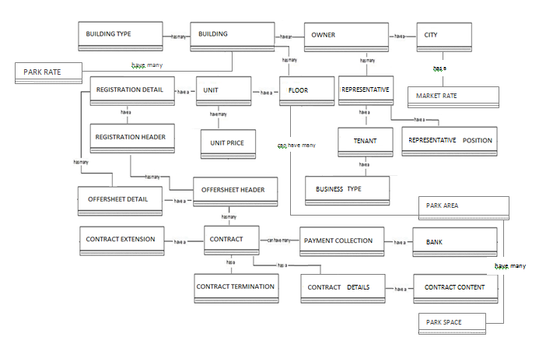

**3.2.2 Database Design**

**3.2.2.1 Database Schema**

